GEOLOGY 155 – Oceanography Lab

Spring Quarter 2004 (11852,SEC 7) INSTRUCTOR: SONJIA M. LEYVA
LAB: W. 12:40 – 2:20 PM OFFICE: PS 221, 323-343-2149
ROOM: PS-215 OFFICE HOURS: M & W 11:30 AM-12:30 PM
WEBPAGE: www.calstatela.edu/faculty/sleyva EMAIL: SLEYVA@CALSTATELA.EDU

Text & Materials:
SYLLABUS And STUDY GUIDE FOR OCEANOGRAPHY FIELD LABORATORY –THE OCEANOGRAPHIC CRUISE ABOARD THE R.V. YELLOWFIN, Ivan P. Colburn. In addition to the text, bring a calculator, color pencils, and a ruler (combination metric/standard scale) to every lab session.

DATE | LAB TOPIC | PAGES | EXERCISE | DATE DUE
9/29 | Introduction & Bathymetry | 58 – 74 | Handout | 10/06
10/06 | Southern California Bathymetry | 10 – 18 | Ex. 1 & 2 (P 60 – 67)  Ex. 3 (P. 68 – 70) | 10/13
10/13 | Light Penetration In The Sea | 19 – 21 | Handout, Ex. 4 (P 71) | 10/20
Oct. 17 | Boat Trip! 12:30 PM |  | Section N, (P. 75 – 95) | 10/20
10/20 | Boat Trip Review |  | Handout | 10/27
10/27 | Midterm Exam
11/03 | Salinity, Dissolved Gasses, Acidity | 22 - 35 | Handout | 11/10
11/10 | Temperature And Density | 36 – 38 | Handout | 11/17
11/17 | Sediments | 39 - 45 | Handout, Ex. 5 (P 72 – 73) | 11/24
11/20 | BEACH TRIP! 10:00 AM |  | Handout | 11/24
11/24 | Shoreline Processes | 58 – 74 | Handout | 12/01
12/01 | FINAL EXAM!

Class Attendance:
Students are expected to attend each laboratory period and to arrive on time. The laboratory period will start with a brief discussion on the techniques and concepts needed for the day’s laboratory assignment. Since it will not be possible to go over these materials more than once during the laboratory period, it is necessary for students to arrive on time. It will be difficult to make up missed laboratory periods. However, if you miss a laboratory period of valid reasons (illness), it will up to you to make arrangements to complete the lab exercise
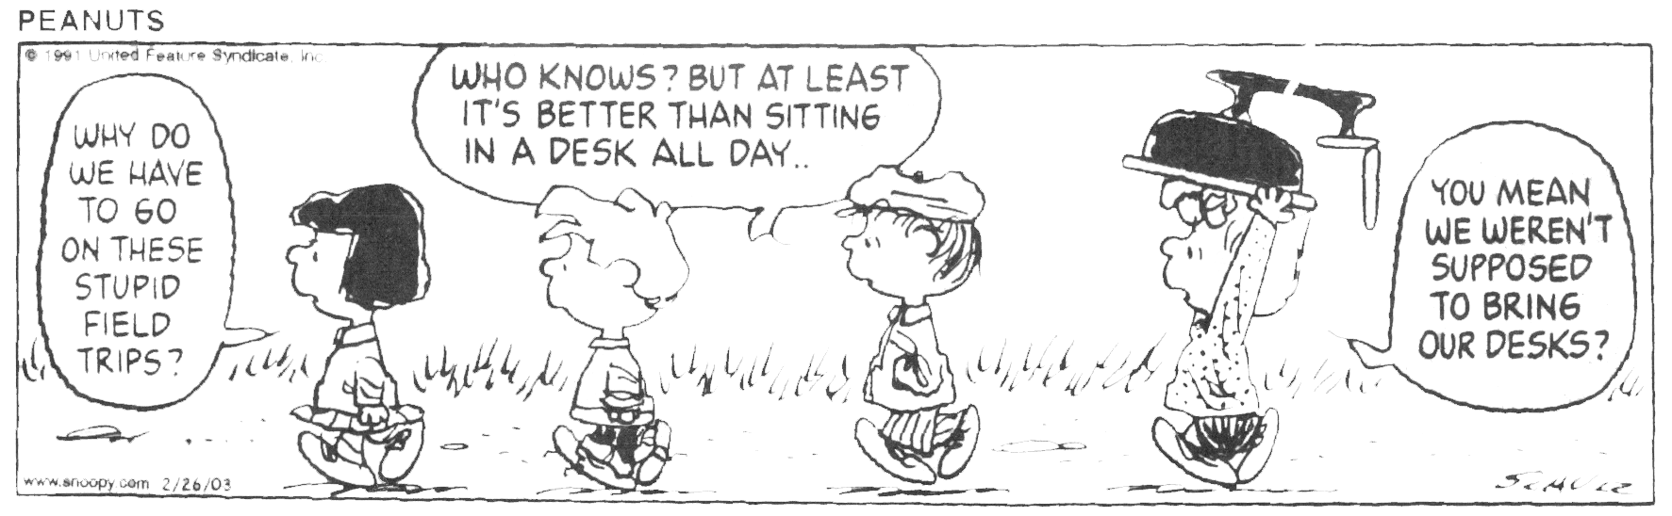

REQUIREMENTS
EXAMS – Two equally weighted exams are scheduled for the course: one midterm and one final. Each exam counts 50 points. Make-up exams will be given only to those who can verify a valid excuse for missing an exam. The make-up will be given at a time that is mutually agreeable to both the student and myself, but must be arranged prior to the initial exam. Failure to take the make-up will result in the missed exam counting in as a zero. Your grades will be available on the class website, www.calstatela.edu/faculty/sleyva/grades/index.html.

LABS - A new laboratory assignment will be given for each laboratory period. The assignments will be due the following week at the beginning of class. Students are encouraged to work together in completing the laboratory work. However, each student should be sure to understand the techniques and concepts involved because midterm and final exam test problems will be very similar to laboratory problems. Labs are due the following week. Missed labs must be made up within two weeks or a grade of 0 (zero) will be given for the lab.

FIELD TRIPS -- Attending the field trips is an absolute requirement. What we learn in class is geared to what we will observe during the field trips. Missing either of the field trips will result in you failing the course. In addition, students are required to complete and sign a waiver before attending the field trip. The waiver and a copy of your paid fee are required prior to the trip.

INTERNET ACCESS - Internet access is suggested for this class because much of the course content will be posted on the class web site, www.calstatela.edu/faculty/sleyva. Access at home or work is fine as long as you can view the web pages regularly and have a reasonably fast connection. If you don't have access at home or work, you can get free access through an account here at Cal State LA. To get a computer account at Cal State LA, go to the Academic Technology Support (ATS) Office in (basement) King Hall D140. You will need identification and proof of registration.

METHODS OF EVALUATION
Total possible class points will come from three equally weighted exams, one research project, and class participation
- Exams – 33 % (2 tests @ 50 points each)
- Labs – 33 % (100 points total)
- Field Trips – 33 % (2 trips @ 50 points each)

You may do up to 20 points of extra credit work to raise you total points earned. All extra credit is due the last day of class – not the day of the final! Your grade is based on your percentage score out of 250 points: A= >90%; B =80-89%; C= 70-79% D= 60-69%; F=< 60%. Your grades will be available on the class website, www.calstatela.edu/faculty/sleyva/grades/index.html.
YOUR LAB GRADE IS WORTH ONE QUARTER (25%) AND YOUR LECTURE GRADE IS WORTH THREE QUARTERS (75%) OF YOUR OVERALL GENERAL GEOLOGY GRADE.

Want to get a good grade? Here’s how:
- Attend every class.
- Take notes and review them after class and before exams.
- Read your textbook.
- Ask questions. You are responsible for studying.

IMPORTANT POLICIES (a.k.a. the “fine print”)
- Make-up exams will be given only to those who can verify a valid excuse for missing a quiz. The make-up will given at a time that is mutually agreeable to both the student and myself. Failure to take the make-up will result in the missed exam counting in as a zero.

- University policy allows a grade of incomplete to be given only to those who have been sick, injured, or have a similar valid excuse. Incompletes will not be given after poor performance in the course.

- If you are repeating any Cal State L.A. course in order to remove a D or an F from your transcript, you must file an academic renewal petition in Administration 101 no later than the last day to add a class. Instructions for doing this may be found under "Academic Renewal" in your Schedule of Classes.

- University policy requires that all students shall be graded in exactly the same fashion. What does this mean? You may not ask for extra assignments or to repeat an exam to improve your grade, or additional assignments after the course is completed.

- The University has a clearly defined policy on Academic Honesty. This policy will be enforced in this class. Cheating and plagiarizing will not be tolerated. Students caught plagiarizing and/or cheating will be subject to the consequences and set forth in the University Catalog, Appendix D - Academic Honesty. You can access it online at: http://catalog.calstatela.edu

- Avoid the hassles. Take the Writing Proficiency Examination (WPE) after you have completed your English Composition and prior to the completion of 135 units in order to avoid a registration hold. The dates for the WPE are published in the Schedule of Classes. Enroll by registering in UNIV 400 and paying the $15 exam fee. Do it now!!!

