Geology 150 Lab Syllabus

GEOLOGY 150 INSTRUCTOR: SONJIA M. LEYVA
GENERAL GEOLOGY LAB (12396, SEC 6) OFFICE: 221 PHYSICAL SCIENCE BLDG.
LAB: TUES. 11:15 AM – 12:55 PM OFFICE HOURS: TUES. 10:30 – 11:00 AM
ROOM: PS-215 OFFICE TELEPHONE: 323-343-2149
WEBPAGE: www.calstatela.edu/faculty/sleyva EMAIL: SLEYVA@CALSTATELA.EDU

Text & Materials:
- Your lab manual is available on-line on our class website: http://www.calstatela.edu/faculty/sleyva/Geol150lab/. You may either download the entire file at one time or print out each lab as needed. NOTE: If you download the entire file, be warned that it is large. You might want to print it out a chapter at a time as not to overload your printer. If you would prefer, you may bring me a recordable CD-ROM and I will copy all of the files onto the CD for you.
- Please bring color pencils and a ruler (combination metric/standard scale) to each class session.

Description:
This general geology laboratory is an introduction to minerals, rocks, maps and plate tectonics. Minerals are the basic building blocks of rocks. To geologists, rocks are the keys to understanding Earth’s history and the rock-forming processes that operate within the Earth and on its surface. Maps are used by geologists to plot data and to examine the patterns of rock on the surface of the earth. At the end of this course students should be able to identify major rock types and minerals, and the students will also be able to work with topographic maps and interpret geologic maps.

Class Attendance:
Students are expected to attend each laboratory period and to arrive on time. The laboratory period will start with a brief discussion on the techniques and concepts needed for the day’s laboratory assignment. Since it will not be possible to go over these materials more than once during the laboratory period, it is necessary for students to arrive on time. It will be difficult to make up missed laboratory periods. However, if you miss a laboratory period of valid reasons (illness), it will up to you to make arrangements to complete the lab exercise.

Requirements:
LABS - A new laboratory assignment will be given for each laboratory period. The assignments will be due the following week at the beginning of class. Students are encouraged to work together in completing the laboratory work. However, each student should be sure to understand the techniques and concepts involved because midterm and final exam test problems will be very similar to laboratory problems. Labs are due the following week. Missed labs must be made up within two weeks or a grade of 0 (zero) will be given for the lab

EXAMS – One midterm and one final exam are scheduled. The exams will be taken without cooperation between students. Labs will be reviewed in class and they must be completed by the assigned time.

FIELD TRIPS -- Attending the field trip is an absolute requirement. What we learn in class is geared to what we will observe during the field trips. Missing the field trip will result in you failing the course.

The University charges a fee of $10 for field trips that require transportation. This fee will cover the cost of transportation only. Meals, for example, are not included. You must pay this fee at the Cashier’s office. In addition, students are required to complete and sign a waiver before attending the field trip. The waiver and a copy of your paid fee is required prior to the trip

INTERNET ACCESS - Internet access is required for this class because much of the course content will be posted on the class web site, www.calstatela.edu/faculty/sleyva. Access at home or work is fine as long as you can view the web pages regularly and have a reasonably fast connection. If you don't have access at home or work, you can get free access through an account here at Cal State LA. To get a computer account at Cal State LA, go to the Academic Technology Support (ATS) Office in (basement) King Hall D140. You will need identification and proof of registration. More information on computer accounts: http://www.calstatela.edu/ats/user/scr/.

Grading:
Total possible class points will come from the exams and worksheets. The points scored on each exam and on the labs will be totaled and a percent determined for each student. A class grade will be assigned according to the following scale: A= 90%; B = 80-89%; C= 70-79% D= 60-69%; F=< 60%. Your grades will be available on the class website, www.calstatela.edu/faculty/sleyva/grades/index.html.

YOUR LAB GRADE IS WORTH ONE QUARTER (25%) AND YOUR LECTURE GRADE IS WORTH THREE QUARTERS (75%) OF YOUR OVERALL GENERAL GEOLOGY GRADE.

General Geology 150 Lab

Course Schedule

DATE | LAB TOPIC | DATE LAB DUE
JAN 06 | Introduction & Mineral Identification #1 | JAN 20
JAN 13 | Mineral Identification #2 | JAN 20
JAN 20 | Igneous Rock Identification | JAN 27
JAN 27 | Sedimentary Rock Identification | FEB 03
FEB 03 | Metamorphic Rock Identification | FEB 10
FEB 10 | MIDTERM MINERAL AND ROCK IDENTIFICATION
FEB 17 | Topographic maps | FEB 24
FEB 24 | Rock Masses and Geologic Maps | MAR 02
MAR 02 | Plate tectonics | MAR 09
MAR 09 | Faults and Earthquakes | MAR 16
MAR 16 | FINAL EXAM! 10:45 - 1:15 P.M.

Important Policies:
Make-up exams will be given only to those who can verify a valid excuse for missing an exam. The make-up will be given at a time that is mutually agreeable to both the student and myself, but must be arranged prior to the initial exam. Failure to take the make-up will result in the missed exam counting in as a zero.

University policy allows a grade of incomplete to be given only to those who have been sick, injured, or have a similar valid excuse. Incompletes will not be given after poor performance in the course.

If you are repeating any Cal State L.A. course in order to remove a D or an F from your transcript, you must file an academic renewal petition in Administration 101 no later than the last day to add a class. Instructions for doing this may be found under "Academic Renewal" in your Schedule of Classes.

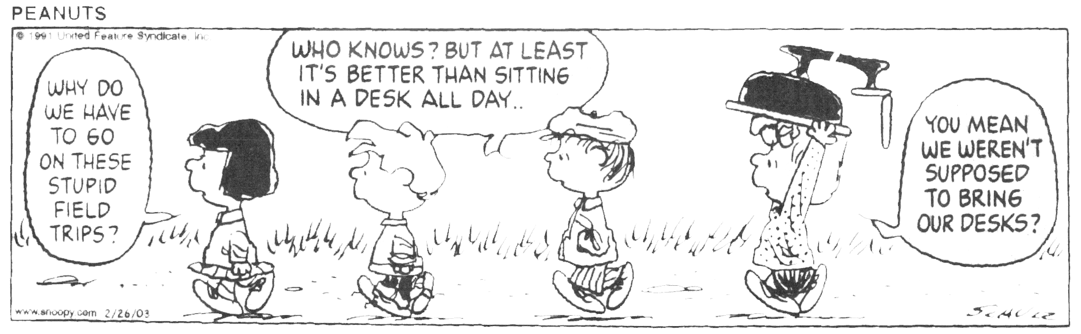
Avoid the hassles. Take the Writing Proficiency Examination (WPE) after you have completed your English Composition and prior to the completion of 135 units in order to avoid a registration hold. The dates for the WPE are published in the Schedule of Classes. Enroll by registering in UNIV 400 and paying the $15 exam fee. Do it now!!!

