**Geology 150 - Geology Laboratory**

**Fall Quarter 2009** (10002, SEC 3) **Instructor**: Sonjia Leyva

**Hours**: M 01:05 – 2:45 PM  **Office:** PS 221, 323-343-2149

**Room**: PS 215  **Office Hours:** M 12:00 – 12:30 PM

**Webpage:** [www.geophile.net/College](http://www.geophile.net/College) **Email:** [sleyva@calstatela.edu](mailto:sleyva@calstatela.edu)

### Course Description: This laboratory class is the second portions of the Geology 150 Earth Revealed class. The laboratory requirement is met through 3 hours of lecture and 1 hour 40 minutes of laboratory time per week in addition to an 8-hour field trip. Fulfills 4 units in the B2 Block of the GE Requirements

### Course Objectives: This general geology laboratory is an introduction to minerals, rocks, maps and plate tectonics. Minerals are the basic building blocks of rocks. To geologists, rocks are the keys to understanding Earth's history and the rock-forming processes that operate within the Earth and on its surface. Maps are used by geologists to plot data and to examine the patterns of rock on the surface of the earth. At the end of this course students should be able to identify major rock types and minerals, and the students will also be able to work with topographic maps and interpret geologic maps.

**Text & Materials:**

1. Geology 150 Laboratory, complied by Sonjia Leyva, available in the bookstore. Or, you may download them BEFORE THE START OR EACH CLASS SESSION at <http://www.geophile.net/College/webpages/Geology.htm>   
   or on WebCT (enroll in class GEOL150_sl_SEC03_W10_CNSS)
2. Color pencils (not crayons or markers)
3. Ruler (combination metric/standard scale)
4. Calculator (not the one on your cell phone)

|  |  |  |  |
| --- | --- | --- | --- |
| **Week** | **Date** | **Topic** | **Week Due** |
| **1** | 1/04 | Mineral Identification | 2 |
| **2** | 1/11 | Igneous Rock Identification | 4 |
| **3** | **1/18** | **Memorial Day – Campus Closed!** | |
| **4** | 1/25 | Sedimentary Rock Identification | 5 |
| **5** | 2/01 | Metamorphic Rock Identification | 6 |
| **6** | **2/08** | **Midterm Exam** | |
| **7** | 2/15 | Geologic Maps & Relative Dating **(extra credit EQ kits due)** | 8 |
| **8** | 2/22 | Plate Tectonics | 9 |
| **9** | 3/01 | Earthquakes **(all extra credit due)** | 10 |
| **10** | **3/08** | **Final exam!** | |

**FIELD TRIP DATE SATURDAY 3/6, 8 TO 5 PM**

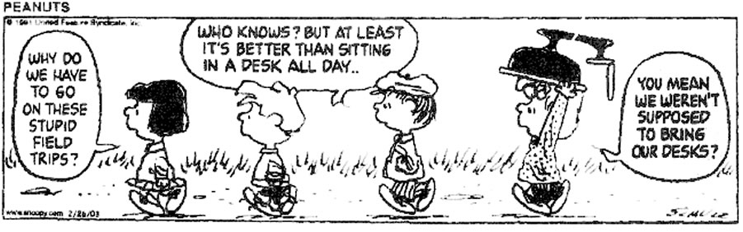

**REQUIREMENTS**

|  |
| --- |
| **Class Attendance:**  Students are expected to attend each laboratory period and to arrive on time. The laboratory period will start with a brief discussion on the techniques and concepts needed for the day's laboratory assignment. Since it will not be possible to go over these materials more than once during the laboratory period, it is necessary for students to arrive on time. It will be difficult to make up missed laboratory periods. However, if you miss a laboratory period of valid reasons (illness), it will up to you to make arrangements to complete the lab exercise. **You will receive 3 points per lab session for attendance (total of 30 points).** |
| **Field Trips:** If your lab is scheduled to have a field trip, **attending the field trip is an absolute requirement**. What we learn in class is geared to what we will observe during the field trip. Missing the field trip will result in you failing the course. Students are required to complete and sign a waiver before attending the field trip. The waiver is required prior to the trip |
| **Lab Reports (15-25 points per lab)** – Students will participate in a variety of laboratory experiments/exercises designed to introduce you to various aspects of Geology. The assignments will be due the following week at the beginning of class. Students are encouraged to work together in completing the laboratory work. However, each student should be sure to understand the techniques and concepts involved because midterm and final exam test problems will be very similar to laboratory problems. **Labs are due the following week.**  **Late submissions will not be accepted**. **Failure to make-up the laboratory activity within two weeks of the original date will result in the missed exam counting in as a zero.** |
| **Exams –** Two equally weighted exams are scheduled for the course: one midterm and one final. Each exam counts 100 points. Make-up exams will be given only to those who can verify a valid excuse for missing an exam. The make-up will be given at a time that is mutually agreeable to both the student and myself, but must be arranged prior to the initial exam. **Failure to take the make-up exam within two weeks of the original exam date will result in the missed exam counting in as a zero.** In addition, the exam question sheet must be returned to me after the exam and after the exam review. Failure to do so will result in a ten (10) point reduction in the student's grade for that exam. Your grades will be available on the class website, [www.calstatela.edu/faculty/sleyva/grades/index.html](http://www.calstatela.edu/faculty/sleyva/grades/index.html). |
| **Weekly Quizzes –** The first ten minutes of each lab period will be devoted to a short 10 point quiz which will cover what we will be doing in lab that day. **It is therefore important to come to lab on time, every time.** Students arriving late but before the end of the quiz will be allowed to take the quiz, but must stop with everyone else. Students arriving after the end of the quiz will not be allowed to take it. |

Want to get a good grade? Here’s how:

1. Attend every class.
2. Take notes and review them after class and before exams.
3. Read your textbook / do the assignments
4. Turn in all work on time
5. Ask questions.
6. .**You are responsible for studying.**

**METHODS OF EVALUATION**

Total possible class points will come from the following assignments:

|  |  |  |  |  |
| --- | --- | --- | --- | --- |
| For classes WITHOUT a field trip | **Assignment** | **Points Possible** | **Total Points** | **% of grade** |
| Lab reports | 25 points per lab | 200 | 40.00% |
| Exams | 100 points each | 200 | 40.00% |
| Weekly Quizzes | 10 points each | 70 | 14.00% |
| Attendance | 3 points per session | 30 | 6.00% |
|  |  | **500** | **100.00%** |

|  |  |  |  |  |
| --- | --- | --- | --- | --- |
| For classes WITH a field trip | **Assignment** | **Points Possible** | **Total Points** | **% of grade** |
| Lab reports | 15 -20 points per lab | 150 | 30.00% |
| Field Trip | 50 points | 50 | 10.00% |
| Exams | 100 points each | 200 | 40.00% |
| Weekly Quizzes | 10 points each | 70 | 14.00% |
| Attendance | 3 points per session | 30 | 6.00% |
|  |  | **500** | **100.00%** |

|  |  |  |  |
| --- | --- | --- | --- |
| For BOTH Classes | **Grade** | **Total Points** | **Points applied to lecture grade (100% = 25 points)** |
| A = >90% | > 450 points | 22.5 - 25.0 points |
| B = 80-89% | 400 – 449.9 points | 20.0 - 22.5 points |
| C = 70-79% | 350 – 399.9 points | 17.5 - 20.0 points |
| D = 60-69% | 300 – 349.9 points | 15.0 - 17.5 points |
| F =< 60% | <300 points | < 15 points |

You may do up to 20 points of extra credit work to raise your total points earned. **All extra credit with the exception of the EQ kit is due the last day of class - not the day of the final!**

YOUR LAB GRADE IS WORTH ONE QUARTER (25%) AND YOUR LECTURE GRADE IS WORTH THREE QUARTERS (75%) OF YOUR OVERALL GENERAL GEOLOGY GRADE.

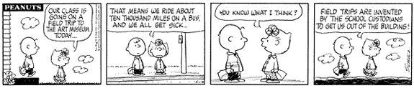**IMPORTANT POLICIES (a.k.a. the “fine print”)**

* **Statement of Reasonable Accommodation**:
* The Department of Geological Sciences faculty members fully support the Americans with Disabilities Act (ADA). The members of the faculty will provide reasonable accommodation to any student with a disability who is registered with the Office of Students with Disabilities (OSD) who needs and requests accommodation. The faculty may wish to contact the OSD to verify the presence of a disability and confirm that accommodation is necessary. The OSD will arrange and provide for the accommodation.
* Reasonable accommodation may involve allowing a student to use an interpreter, note taker, or reader; accommodation may be needed during class sessions and for administration of examinations. The intent of the ADA in requiring consideration of reasonable accommodation is not to give a particular student an unfair advantage over other students, but simply to allow a student with disability to have an equal opportunity to be successful.
* **Student Conduct**:
* Student conduct is viewed as a serious matter by the faculty members of the Department of Geological Sciences. The Department faculty members assume that all students will conduct themselves as mature citizens of the campus community and will conduct themselves in a manner congruent with university policies and regulations. Inappropriate conduct is subject to discipline as provided for in Title 5, California Code of Regulations (see student conduct: rights and responsibilities, and student discipline, CSULA General Catalog). Academic honesty is expected of all students in the Department, in accordance with University policy. There are established university reporting procedures if a student is suspected of committing an academically dishonest act.
* The University has a clearly defined policy on Academic Honesty. This policy will be enforced in this class. **Cheating and plagiarizing will not be tolerated.** Students caught plagiarizing and/or cheating will be subject to the consequences and set forth in the University Catalog, Appendix D - Academic Honesty. You can access it online at: <http://catalog.calstatela.edu>
* **Make-up exams:** Make-up exams will be given only to those who can verify a valid excuse for missing a quiz. The make-up will given at a time that is mutually agreeable to both the student and myself. **Failure to take the make-up exam within two weeks of the original exam date will result in the missed exam counting in as a zero.**
* **Grading:**
* University policy allows a grade of incomplete to be given only to those who have been sick, injured, or have a similar valid excuse. A grade of “incomplete” will not be given after poor performance in the course.
* If you are repeating any Cal State L.A. course in order to remove a D or an F from your transcript, you must file an **academic renewal petition** in Administration 101 no later than the last day to add a class. Instructions for doing this may be found under **"Academic Renewal"** in your Schedule of Classes.
* University policy requires that all students shall be graded in *exactly* the same fashion. What does this mean? You may not ask for extra assignments or to repeat an exam to improve your grade, or additional assignments after the course is completed.
* **Avoid the hassles.** Take the Writing Proficiency Examination (WPE) after you have completed your English Composition and prior to the completion of 135 units in order to avoid a registration hold. The dates for the WPE are published in the Schedule of Classes. Enroll by registering in UNIV 400 and paying the $15 exam fee. Do it now!!!